

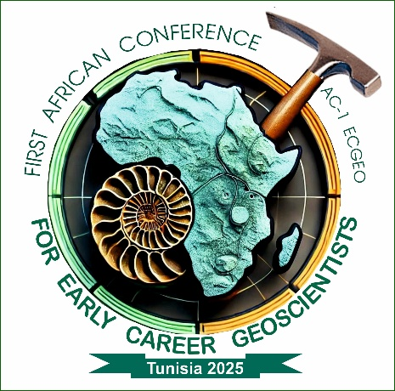

**S T E E R I N G**

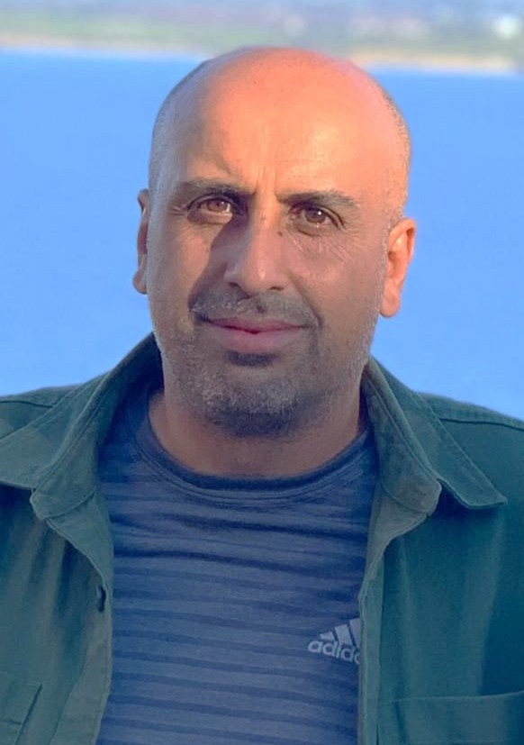

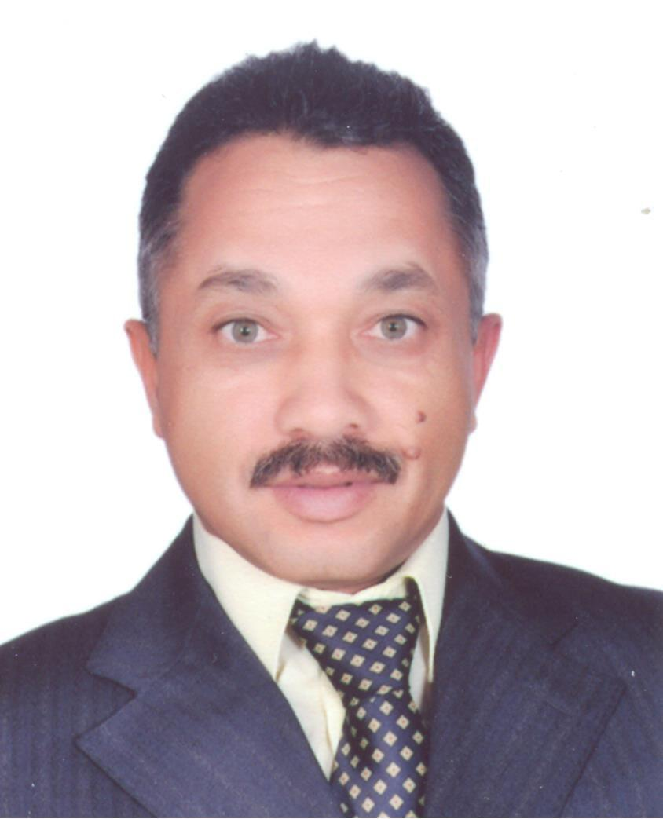

**C O M M I T T E E**

**Senior Coordinators**

**Prof. Fetheddine Melki Assoc. Pr. Nadhem Brahim**

**Fetheddine.Melki@fst.utm.tn**[**Nadhem.Brahim@fst.utm.tn**](mailto:Nadhem.Brahim@fst.utm.tn)

|  |  |  |  |  |  |
| --- | --- | --- | --- | --- | --- |
| 1 |  | GWC | Global Warming  & Climate Change | | |
| CHAIRS | | N. Kallel | | **FSS** | **ACADEMIC**  **COLLABORATORS** |
| Amina Mabrouk | | **FST** |
| Advisory  Co-Chairs | | Heykel Sellami | | **CERTE** | Martial Bernoux  (FAO, Italy) |
| Nadhem Brahim | | **FST** |  |

|  |  |  |  |  |  |
| --- | --- | --- | --- | --- | --- |
| 2 |  | WSG | Water and Sediment Geochemistry,  & Environment | | |
| CHAIRS | | | Fedoua Hamzaoui | **FST** | **ACADEMIC**  **COLLABORATORS** |
| Moncef Zaïri | **FSS** |
| Advisory  Co-Chairs | | | Semia Khadhar | **CERTE** | Prof. Cüneyt Güler (Mersin, Turkey) |
| Khawla Tlili | **FSB** |
| Boutheina Farhat | **FST** | Lahcen Zouhri  (Beauvais, France) |
| Emna Erraies | **FSB** | Cherifa Abdelbaki  (Tlemcen, Algeria) |

|  |  |  |  |  |  |  |
| --- | --- | --- | --- | --- | --- | --- |
| 3 |  | EGR | | Environmental Geosystems  & Risk Management | | |
| CHAIRS  Advisory  Co-Chairs | | | Abdellaziz Sebei | | **FST** | **ACADEMIC**  **COLLABORATORS** |
| Habib Abida | | **FSS** |
| Amor Ben Moussa | | **ISSTE** | Isabel Margarida  (Braga, Portugal) |
| Meriem Jemli | | **FSB** | Nabiha Ben M’barek (ANPE, TUNISIA) |
| Mohamed Kefi | | **CERTE** | Aïssa Hleimi (DGRE, Tunisia) |

|  |  |  |  |  |  |
| --- | --- | --- | --- | --- | --- |
| 4 |  | MGC | Marine Geology, Coastal Dynamics: Risk & Management | | |
| CHAIRS | | Oualid Oueslati | | **FST** | **ACADEMIC**  **COLLABORATORS** |
| Hanene Saidi | | **FST** |
| Advisory  Co-Chairs | | Mohamed Ali Tagorti | | **ISBM** | Valérie Mesnage  (Rouen, France) |
| Maher Gzam | | **ISSTEG** | Imen Turki  (Rouen, France) |
| Antonis Chatzipavlis, (Aegian Univ., Grece) |

|  |  |  |  |  |  |  |
| --- | --- | --- | --- | --- | --- | --- |
| 5 |  | HSD | | Hydrogeology, Water Resources: Management and Sustainable Development | | |
| CHAIRS | | | Ismail Chenini | | **FST** | **ACADEMIC**  **COLLABORATORS** |
| Belgacem Agoubi | | **ISSTEG** |
| Feten Horriche | |  |
| Advisory  Co-Chairs | | | Younes Hamed | | **FSGa** | Aïssa Hleimi  (DGRE, Tunisia) |
| Anis Chkirbene | | **INAT** |
| Mohsen Ben Alaya | | **INRAP** | Pistre Severin (Montpellier, France) |
| Soumaya Hajji | | **FSB** | Halima Belalite  (Mila, Algeria) |
| Emna Boughariou | | **FSS** |

|  |  |  |  |  |  |
| --- | --- | --- | --- | --- | --- |
| 6 |  | MGR | Mining Georesources | | |
| CHAIRS | | | Foued Souissi | **FST** | **ACADEMIC**  **COLLABORATORS** |
| Ali Tlili | **FSS** |
| Advisory  Co-Chairs | | | Nejib Jemmali | **FSGf** | Rabah Laouar  (Annaba, Algeria) |
| Hechmi Garnit | **FST** |
| Riadh Abidi | **FST** |

|  |  |  |  |  |  |
| --- | --- | --- | --- | --- | --- |
| 7 |  | MGR | Mineral Georesources: Geomaterials | | |
| CHAIRS | | | Hafsia Ben Rhaiem | **FSB** | **ACADEMIC**  **COLLABORATORS** |
| Fakher Jemoussi | **CERTE** |
| Moufida Ben M’barek | **FSB** |
| Advisory  Co-Chairs | | | Ali Sdiri | **FSS** | Abdesslem Ben Haj Amara (FSB, Tunisia) |
| Tahar Aloui | **FSS** |
| Mongi Felhi | **ENIS** | Bachir Laamouri (Biskra, Algeria) |
| Hend Azzouz | **FST** | Yesser Ben Amor  (Tunisia) |
| Wissem Guellala | **ESBAM** |

|  |  |  |  |  |  |
| --- | --- | --- | --- | --- | --- |
| 8 |  | ERP | Energetic Georesources  & Petroleum Geology | | |
| CHAIRS | | | Amina Mabrouk | **FST** | **ACADEMIC**  **COLLABORATORS** |
| Semi Khomsi | **CERTE** | Moncef Saïdi  (ETAP, Tunisia) |
| Advisory  Co-Chairs | | | Sadok Jabrallah | **FSB** | Abdellatif Touil  (SITEP, Tunisia) |
| Ismail Trabelsi | **CERTE** |
| Adnene Amiri | **FST** |

|  |  |  |  |  |  |
| --- | --- | --- | --- | --- | --- |
| 9 |  | PSP | Pedology & Soil Processes, Geomorphology | | |
| CHAIRS | | | Hatem Brahim | **FSB** | **ACADEMIC**  **COLLABORATORS** |
| Hakim Bouajila | **FSG** |
| Advisory  Co-Chairs | | | Nadhem Brahim | **FST** | Giuseppe Lo papa  (Palermo Italy) |
| Fatma Wassar | **ISSTEG** | Carmello Dazzi (Palermo, Italy) |

|  |  |  |  |  |  |  |
| --- | --- | --- | --- | --- | --- | --- |
| 10 |  |  | AIG | Artificial Intelligence in Geosciences, Applied Geomatics | | |
| CHAIRS | | | Salwa Saïdi | | **FST** | **ACADEMIC**  **COLLABORATORS** |
| Ibtissem Amri | | **FSB** |
| Advisory  Co-Chairs | | | Hayet Chihi | | **CERTE** | Cédric John (London, UK) |
| Tarek Sboui | | **FST** |
| Meriem Labiadh | | **FSB** | Riheb Hadji (Sétif, Algeria) |
| Semi Khemiri | | **FST** | Yahya Habibi (Batna, Algérieà |

|  |  |  |  |  |  |
| --- | --- | --- | --- | --- | --- |
| 11 |  | SEP | Sedimentary Dynamics  & Economic Potential | | |
| CHAIRS | | | Mohamed Soussi | **FST** | **ACADEMIC**  **COLLABORATORS** |
| Med Faouzi Zagrarni | **ISSTEG** |
| Advisory  Co-Chairs | | | Narjess El Euch | **FST** | Nabil Dfeflia (Tebessa, Algeria) |
| Abir Chihaoui | **FSGb** |
| Amel Mhamdi | **FST** | Fouad Djaiz  (Batna, Algeria) |
| Besma Mardessi | **FSS** |

|  |  |  |  |  |  |
| --- | --- | --- | --- | --- | --- |
| 12 |  | PPS | Paleontology, Paleodiversity  & Stratigraphy | | |
| CHAIRS | | | Nadia Gaaloul | **CERTE** | **ACADEMIC**  **COLLABORATORS** |
| Amel Chakroun | **FST** |
| Zeineb Amri | **ISAMK** |
| Advisory  Co-Chairs | | | Abdallah Khazri | **FSB** | Sihem Salmi-Laouar (Annaba, Algeria) |
| Houaida Sallouhi | **FSB** |
| Ahlem Amri | **CERTE** | Miloud Ben Hammou (Oran, Algeria) |
| Nadia Ben Mokhtar | **FSGb** | Rachid Touansa  (Batna, Algeria) |

|  |  |  |  |  |  |  |
| --- | --- | --- | --- | --- | --- | --- |
| 13 |  | | EGR | Exploration Geophysics  & Natural Resources | | |
| CHAIRS | | Hajer Azaiez | | | **CERTE** | **ACADEMIC**  **COLLABORATORS** |
| Kawthar Sbei | | | **FST** |
| Rihab Guellala | | | **CERTE** |
| Advisory  Co-Chairs | | Imen Hamdi | | | **FSB** | Saïd Maouche (CRAAG, Algeria) |
| Dorra Tanfous | | | **ISBT** |
| Mohamed Dhaoui | | | **CERTE** |
| Nesrine Frifita | | | **FSGb** | Heifa Boussiga(INAT, Tunisia) |

|  |  |  |  |  |  |  |
| --- | --- | --- | --- | --- | --- | --- |
| 14 |  | | SGT | Structural Geology, Tectonics | | |
| CHAIRS | | Ferid Dhahri | | | **FSGb** | G. Booth Rea  (Granada, Spain) |
| Mohamed Gharbi | | | **CERTE** |
| Advisory  Co-Chairs | | Nejib Bahrouni | | | **ONM** | Mustapha Meghraoui  (Stratsbourg, France) |
| Riadh Ahmadi | | | **FSS** |
| Mohamed Montassar Ben Slama | | | **FST** | Abdelmajid Chouabi  (Annaba, Algeria) |
| Kais Laridhi | | | **FST** | Zakaria Hamimi  (Benha, Egypt) |

|  |  |  |  |  |  |  |
| --- | --- | --- | --- | --- | --- | --- |
| 15 |  | | RSM | Rock & Soil Mechanics, Geotechnics, Civil Engineering | | |
| CHAIRS | | Moufida el Mey | | | **FST** | **ACADEMIC**  **COLLABORATORS** |
| Hamdi Essaieb | | | **ENIT** |
| Advisory  Co-Chairs | | Yahya Moumni | | | **FSB** | Ali Athamena (Batna, Algeria) |
| Mohamed Achite  (Chlef, Algeria) |
| Heythem Msaddak | | | **FST** | Nejib Sassi  (Mghira, Tunisia) |

|  |  |  |  |  |  |  |
| --- | --- | --- | --- | --- | --- | --- |
| 16 |  | | MPG | Mineralogy, Petrology & Geodynamics | | |
| CHAIRS | | Hanene Mattoussi | | | **FST** | **ACADEMIC**  **COLLABORATORS** |
| Mouna Mekki Azzouzi | | | **FSB** | Moulley Charaf Chabou (Sétif, Algeria) |
| Delphine Bosc (Montpellier, France) |
| Advisory  Co-Chairs | | Riadh Abidi | | | **FST** | Lakhdhar Bouabsa  (Tamanrassat, Algeria) |
| Semia Kassaa | | | **FST** |

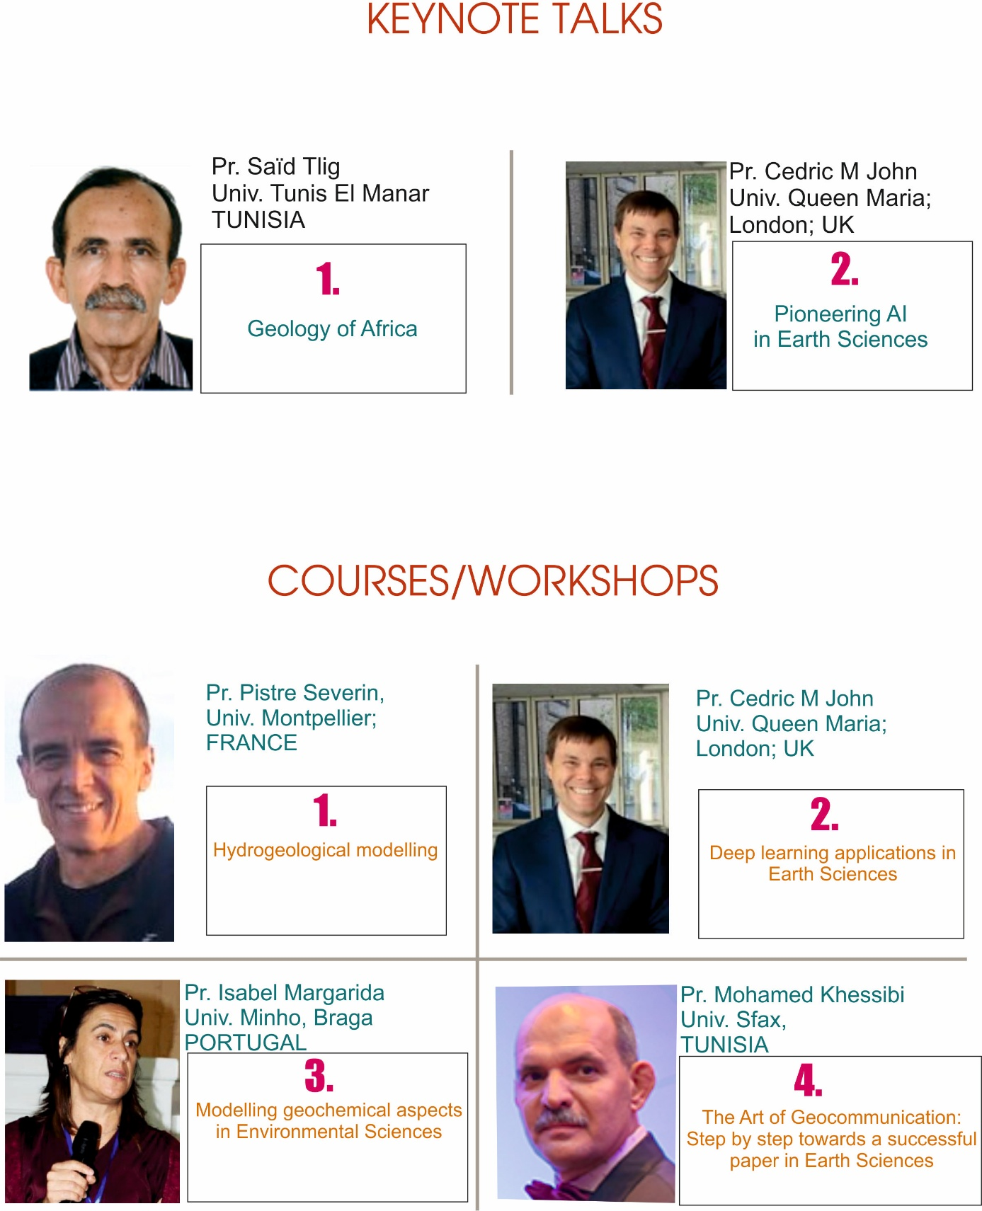

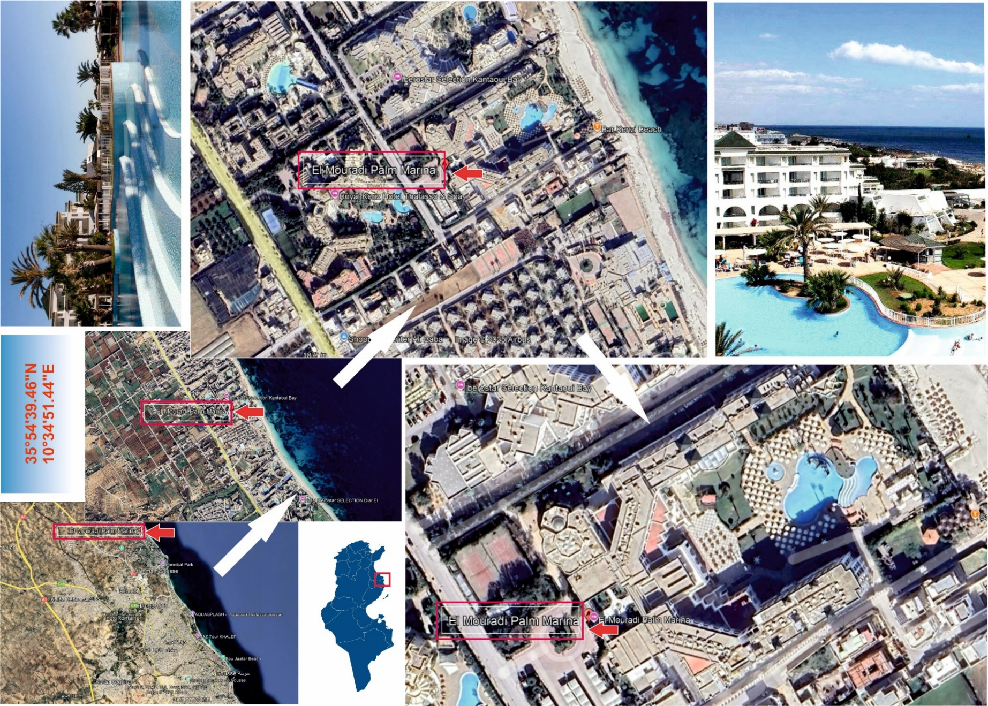



**CONFERENCE VENUE**

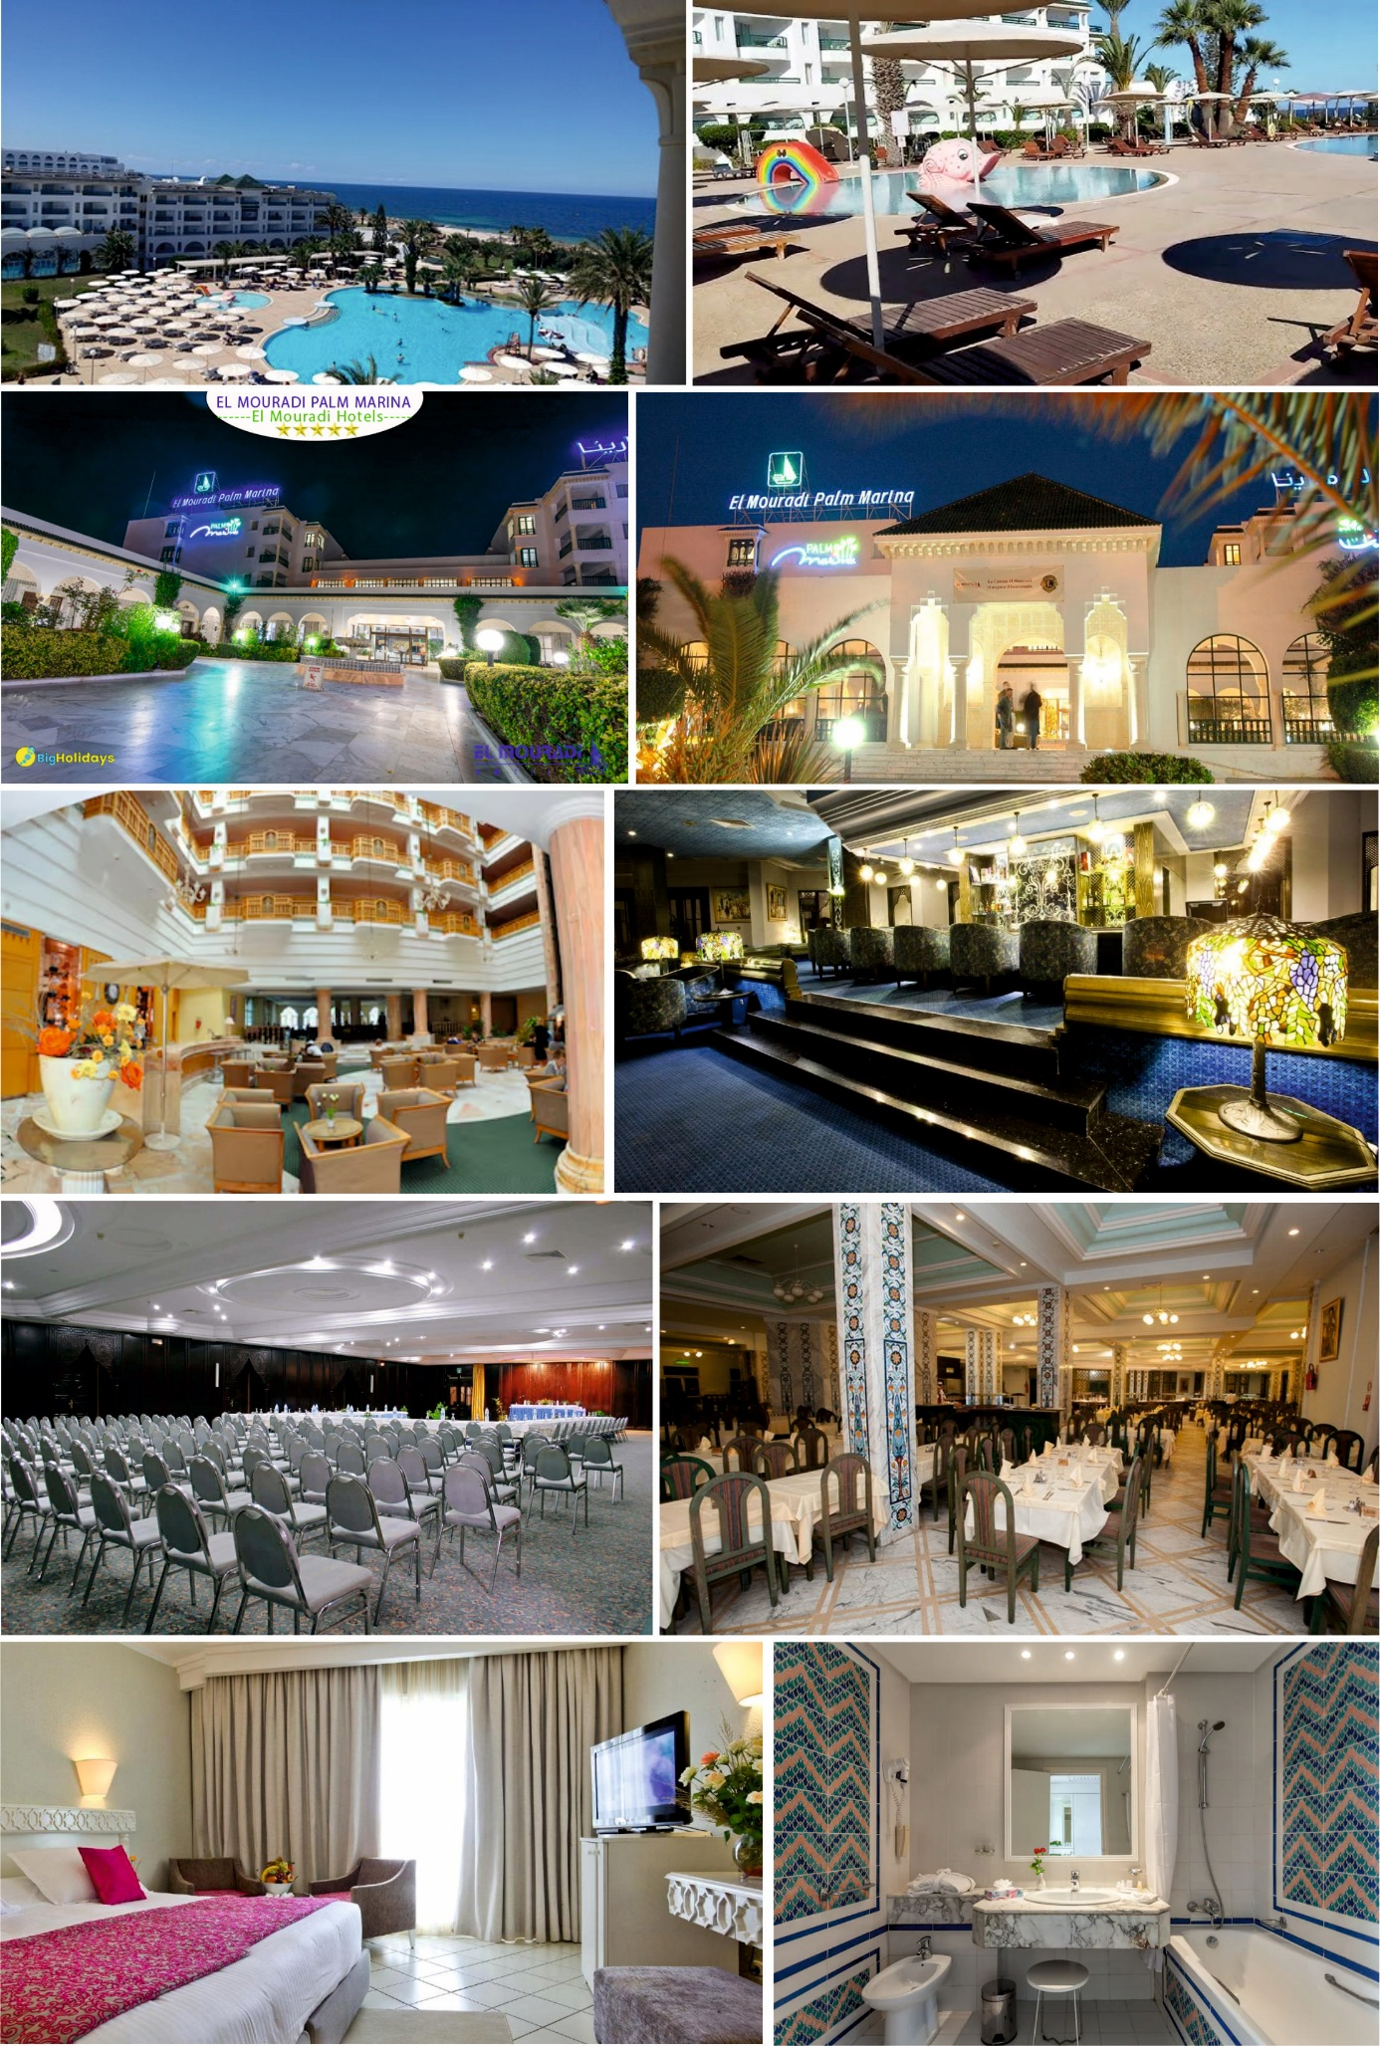



**FIELD TRIPS**

**FT 1 : Geology and Geotourism in North-Central Tunisia**



**DAY 1 (December 3rd 2025)**

**The Oudhna Roman Ruins and the Temple of Water in Zaghouan. Upper Jurassic-Cretaceous unconformity (Hammam Zriba)**



**DAY 2 (December 4th 2025)**

**Cultural Heritage of El Kef Medina, K/T Boundary GSSP, Jugurta Tableland**

**FT2 : Geology and Geotourism in Southern Tunisia**



**DAY 2 (December 4th 2025)**

**The lunar landscape of Semar, The Earth Museum of Tataouine, the Chenini ancient City,**

**The Mrabtine « Ksar » (palace).**

**The unique outcrop of marine Permian in Africa, Troglodyte houses of Matmata.**

**DAY 1 (December 3rd 2025)**

**REGISTRATION AND ACCOMMODATION FEES**

|  |  |  |  |  |  |  |  |  |  |  |  |
| --- | --- | --- | --- | --- | --- | --- | --- | --- | --- | --- | --- |
| *ALL FEES ARE IN EUROS  Formula A : Conference materials  3-day session attendance, 2- night accommodation, all inclusive meals, Coffee breaks, Gala Party  Formula B : Conference materials  2-day session attendance, 1- night accomodation, all inclusive meals, Coffee breaks, Galar Party  Formula C : Conference materials  Attendance for 1 day, 1 lunch, 2 Coffee breaks. | LOW-INCOME COUNTRIES *(please, see list below)* | | | | | | OTHER COUNTRIES | | | | |
| **Registration fees** | | | | **1**  **Field trip**  (+acco-  mmodation  **1** night) | **1**  **WSh./**  **Course**  3 sessions | **Registration fees** | | | **1**  **Field trip**  (+acco-  mmodation  **1** night) | **1**  **WSh./**  **Course**  3 sessions |
| **Formula**  **A** | | **Formula B** | **Formula C** | **Formula**  **A** | **Formula**  **B** | **Formula**  **C** |
| Early Career Geoscientist /  Retired Researcher | **220** | | **150** | **100** | **70** | **50** | **350** | **200** | **150** | **100** | **80** |
| Senior Researcher | **320** | | **200** | **120** | **100** | **-** | **450** | **300** | **160** | **150** | **-** |
| Industrial/Professional Researcher / Exhibitor | **450** | | **300** | **150** | **150** | **100** | **600** | **400** | **250** | **250** | **150** |
| Accompanying person  (spouse or family member) | Less than 12 years | **50** | **30** | **-** | **40** | **-** | **80** | **60** | **-** | **50** | **-** |
| others | **100** | **60** | **-** | **60** | **-** | **120** | **80** | **-** | **80** | **-** |
| One Extra-night (before or after the conference) | **60** | | | | | | **80** | | | | |

**List of Low & Lower Middle Income Countries (World Bank Data):** *Afghanistan, Algeria, Angola, Bangladesh, Benin, Bhutan, Bolivia, Burkina Faso, Burundi, Cabo Verde, Cambodia, Cameroon, Central African Republic, Chad, Comoros, Congo, Congo Dem. Rep., Côte d'Ivoire, Djibouti, Egypt, Eritrea, Eswatini, Ethiopia, Gambia, Ghana, Guinea, Guinea-Bissau, Haiti, Honduras, India, Irak, Iran, Jordan, Kenya, Kiribati, Kyrgyz Republic, Lao PDR, Lebanon, Lesotho, Liberia, Libya, Madagascar, Malawi, Mali, Mauritania, Micronesia, Mongolia, Morocco, Mozambique, Myanmar, Namibia, Nepal, Nicaragua, Niger, Nigeria, Pakistan, Palestine, Papua New Guinea, Philippines, Rwanda, Samoa, São Tomé and Principe, Senegal, Sierra Leone, Solomon Islands, Somalia, Sudan, Sri Lanka, Sudan, Syria, Tajikistan, Tanzania, Timor-Leste, Togo, Tunisia, Uganda, Ukraine, Uzbekistan, Vanuatu, Vietnam, Yemen, Zambia, Zimbabwe.*

***\*For early career geoscientists ; a copy of a student enrollment card for the academic year 2024-2025, or an attestation justifying a period of work in a geological domain less than 3 years, is essential.   
* All prices include taxes and fees ; however, registrants must pay any transfer costs incurred by bank.***

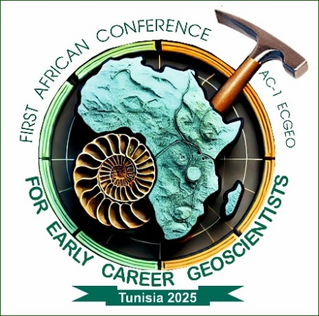

**AWARDS**

**AND**

**HONORS**

For each topic of the conference, the best oral presentation and/or poster will be awarded, and a certificate of achievement delivered.

Honor and recognition awards will be dedicated to particular guests from Africa as well as the retired legends of Geology as proposed by the organizers and the national delegates.

*Most of the awards will be decerned during the Gala party programmed for the second evening of the conference. The others are planned for the opening and closing ceremonies.*

**JOURNAL SPECIAL ISSUES**

*Authors of the top oral presentations will be invited to submit an extended version of their research for publication as a paper in one of the seven high-quality journals associated with the Conference. Negotiations with the editorial boards of these journals have been underway for the past three months, and three of them have already reached an agreement. We are actively working to secure agreements with the remaining journals, aiming to provide a diverse selection of outstanding research for publication. Further details, including the names and topics of the journals, will be published in the second circular.*

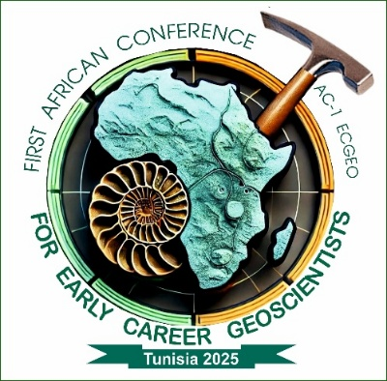**Some practical rules:**

**how to register to the conference**

Our website is currently under construction and is expected to be operational within the next few weeks. In the meantime, please complete the registration form attached to the first circular and adhere to the guidelines for abstract presentation. After filling out the registration form and preparing your abstract, please submit them to one of the following senior coordinators based on your abstract topic:

*Professor Fetheddine Melki (**Fetheddine.Melki@fst.utm.tn**), for ***fundamental geology*** topics (**8 to 12**), or

*Associate Professor Nadhem Brahim (**Nadhem.brahim@fst.utm.tn**), for ***Applied Earth Science topics*** (**1 to 7**).

* the info desk of the conference (all topics): **ac1_ecgeo2025@hotmail.com**

**You will receive an acceptance notification shortly after the review process is completed.**

**Final Words**

On behalf of the conference leadership team and all the steering committees, I would like to extend my best wishes to all active coordinators and members as we approach the final stages of preparation for the **1st African Conference for Early Career Geoscientists.**

To all participants, Welcome to Tunisia and to the African Geosciences community here; I am confident that you will find this experience rewarding. Let us seize the opportunity over the conference three days to strengthen our relationships and collaboratively build a bright future for our young geoscientists. I firmly believe that the ambitious project we are shaping together, which began as an idea fueled by a legitimate dream, will come to life through our shared determination: its success being simply a matter of time; together we can.

I sincerely hope to see a respectful number of you participating in the conference. Nevertheless, thank you for understanding that the number of places will be really limited, as our concern is to ensure the necessary scientific rigor and to provide the best service in a pleasant atmosphere. Therefore, the first abstracts submitted will be the first to be reviewed and accepted: first come, first served.

Finally, please feel free to share any proposals you believe would be constructive for the conference. We will give them the careful consideration they deserve and will be included in our second circular.

All the best, **The Conference General Chair**